Participatory Causal Modelling

Session protocol and semi-structured interview initial questions

# Session(s) structure

The structure is designed to accommodate creating the graphical causal model (GCM) with a single expert, or with a group. Sections of the process that will always be conducted individually or as a group are noted below.

Sections 4 and 5 may be omitted when the models are drawing from a limited range of experts, in which case the focus is less on the diverse understanding of the system and more on the elicitation process and final product.

|  |  |  |
| --- | --- | --- |
| Section | Description | Data collection |
| 1. Introduction and familiarity questions [~20min] | This includes a short tutorial on graphical causal modelling (if required) as well as questions to help ascertain the participants level of domain and modelling expertise. | Responses to familiarity questions collected (on paper or digital). |
| 2. Causal model co-design [~60min] | Participants are guided through creating a GCM of their system. This is set up in two phases: an exploratory phase followed by a formalisation phase. | Video, audio recording to capture model development and participants. |
| 3. Reflection on model creation [Individual only, ~40min] | Participants reflect on the process of co-creating the GCM, using the images of the model creation as prompts. | Recorded semi-structured interview. |
| 4. Causal model amalgamation [Group only, ~45min-60min] | Participants that have built models of the same system, separately, are brought together to compare their models. | Images of amalgamated model taken at regular intervals. Possibly recorded? |
| 5. Reflection on model amalgamation [Individual only, ~30min] | Participants reflect on the process of comparing their own model with others. | Recorded semi-structured interview |

## Running online - tech

To share screen in Teams and still record the participants:

* Start recording.
* Share “Window” of browser with app doing drawing (currently [Loopy](https://efa.unisa.edu.au/Loopy/) / [simple Loopy](https://ncase.me/loopy/) or [DAGitty](https://www.dagitty.net/) are the best options).
* This should record participants as well – but test this again before running session! Default settings can change in apps.
* Drawing apps like Loopy can be easier using a screen mirror onto a tablet.

# Section 1: Introduction and familiarity questions

## Initial questions - Introduction

#### Why are you interested in modelling this system?

This aimed understand the participant’s aims, and to help the facilitator frame where to begin in constructing the causal model, and to re-direct and bound the discussion where required.

Where do you place yourself from novice / curious to expert in understanding X [the system]?

Participants place themselves on a continuum from “novice” to “expert”. To help guide this they were prompted to think about how difficult it is to find someone in their organisation that knows more about the system of interest than them, as well as if they have published or researched in the area (for academics).

This helps understand the level of domain expertise of the participant(s).

How comfortable are you with statistical models?

(with verbal prompts to help guide participants in brackets).

1. *Not at all comfortable* (coefficient is a dirty word).
2. *A little bit comfortable* (ok using / interpreting a regression model).
3. *Comfortable without being an expert* (could write up a results section).
4. *Very comfortable / expert* (could explain logistic regression to a friend).

This helps understand the participants technical / modelling knowledge.

#### How familiar are you with causal DAGs / graphical causal models?

* 1. *Not at all familiar.*
  2. *Aware of them.*
  3. *Familiar without being an expert* (might know about mediators, confounds, or similar constructs such as Causal Loops Diagrams).
  4. *Very familiar / expert* (can visually inspect a DAG to suggest possible adjustment sets – see example below).

For the last part, a possible 'test' example could be given the following diagram:

If we wanted to understand the effect of *X* on *Y*, which variables should we include in our adjustment set? (Answer - *A* but not *B* or *C*)

## Causal modelling tutorial

Informed by the responses to the previous questions, a short tutorial in the minimal requirements for causal modelling will be conducted. The aim of the tutorial is to ensure the participants understand the following key graphical conventions and their interpretation:

* Nodes represent variables / things that are important to the system. They do not need to be measurable, but that does help later.
* (Directed) edges represent the flow of causation. This is not deterministic - it is more like a flow of influence.
* Possible augmentation of directed edges, to include more information about the kind of influence that one node has on another. This can be in the form of:
  + 1. Polarity, via a + or – next to the edge or a green or red colour. This indicates if the cause has a positive or negative impact on the effect.
    2. Strength of influence, via shading / line weight or number of lines. This indicates strong / weak relationships between variables.
    3. A function, or class of functions, indicating the kind of relationship (such as linear, etc). This is highly formalised and would only be used with participants comfortable with such claims.

Participants **do not need to understand the technical requirements of a DAG** (no loops, for instance), only the basic rules of the visual formalism. These can be introduced later if needed, during the formalisation stage of the causal model co-creation.

To facilitate the tutorial, the following example will be used as a guide:

Imagine we believe there is a relationship between the size of a students home library (the number of books they have at home) and their academic outcomes. We would represent this as:

If we then think that 'home library' is what has an influence on 'academic outcomes' we would change the diagram to:

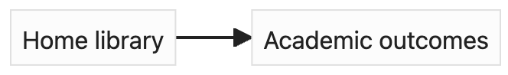

But suppose we think of a third variable that indicates socio-economic disadvantage that the student comes from, and we think that it influences both the home library and the academic outcomes:

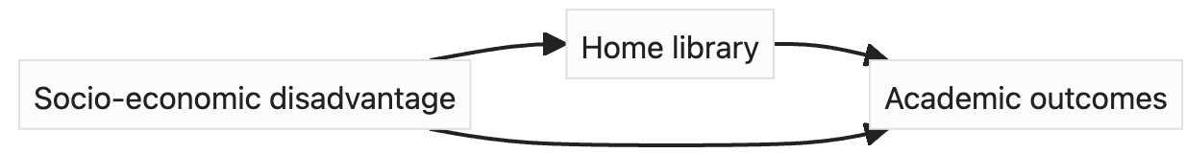

We might even indicate the 'polarity' of the edges - do they positively or negatively influence along the causal path?

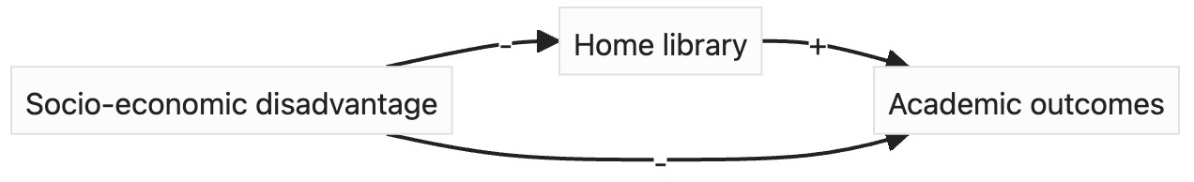

We might even have a notion that some edges are stronger than others, and can give them more a thicker line:

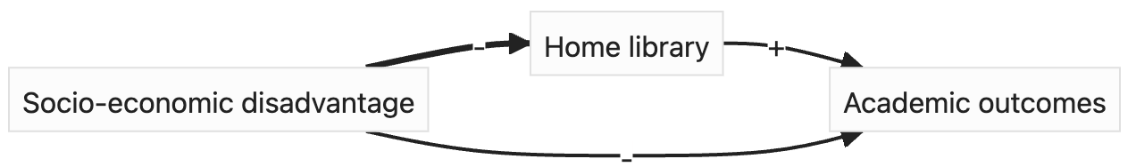

# Section 2: Causal model co-design

The co-design process will evolve as needed, however some initial questions should help in getting started and moving forward when stuck. This section has three parts: a brief outline of the thinking process, an exploratory phase, and lastly the model formalisation.

## Thinking with models

Participants are introduced to three concepts to help frame their thinking during the model construction.

### Bounding the model

It is important that this model will not necessarily encompass *all* of the problem. At some point it will be necessary to describe what is “in” and what is “out” - to provide adequate *bounds* around the model. These bounds are set on both which variables to include (or not), but also the potential value of those variables (such as only looking at Secondary students). Participants will be reminded that time is a critical variable when thinking about causality, so it is probable that some temporal bounding of the problem will be required (such as a model that is relevant only over the course of a subject length).

### Granularity of the model

Related to which variables to include is how “precise” or “finely-grained” these variables should be. There is no right answer here – more detailed variables offer more explanation and precision but will result in a large, unwieldy model that is harder to understand. A GCM can be as small as 2 nodes (course granules) and still be informative, but as more detail is added and it becomes finer grained (more nodes, splitting nodes into parts) the GCM also becomes unwieldy. A balance needs to be struck with the participant, but as a rule of thumb keeping the number of initial nodes under 10 – 12 is a good rule, and interesting discussions can happen with 3 or more.

### Moving between the general and the specific

Although the model will describe how the system works *in general* it can be challenging to remain thinking precisely about a system in the abstract for the whole time. Participants will be encouraged to notice when they are stuck, and attempt to move from the general, abstract thinking to thinking of a specific example, or story, related to the model. This can help negotiate how the causal paths might work, which can then be mapped back to the general GCM.

## Exploration

Initially the space of possible GCMs will need to be explored to scope (1) what variables to initially include, and (2) how granular these need to be.

#### What is the outcome variable you are interested in?

This is a typical way to start the modelling process. Once this is decided, then it can be followed with “what else influences this?”

#### What is important to this system? (Listing factors)

This is another way to start, by simply listing the key factors / variables that are important to the system in question.

## Formalisation

Once the beginnings of a GCM is available it can be interrogated to see if it matches the participants understanding of the system, and also pushed towards a more formal model. A more formal model includes more detail on the edges (such as direction, polarity, or weight), as well as adhering to other rules such as no-loops in the case of a Causal DAG.

*Note that that general approach is listing factors (potentially starting with the outcome), structuring and arranging outcomes spatially, then connecting factors together. The connections then give rise to further questions about the model.*

### Ordering / grouping of factors

An optional intermediate step between listing the important factors and drawing edges between them is to order or structure them in some way. The participant(s) could:

* Order chronologically (left to right). This can help in drawing edges – they should generally always move to the right. This might be too difficult in systems with lots of feedback – but this is also an insight!
* Order by importance (top to bottom). This can help exclude nodes that may not be required, or group nodes together as some ‘higher-level’ construct.
* Order by both, in a 2-D plane.
* Structure them around the outcome in related sections. This can help inform where connections might occur.

### **Interrogating possible edges**

Once key variables are placed on the GCM, then each possible connection between two nodes can be asked:

#### Is there a link between these two nodes?

#### What direction does influence flow?

### **Interrogating possible paths**

As more detail comes into the GCM it is necessary to begin comparing the flow of influence through the various causal paths in the GCM. The simplest form of this is understanding if a mediator is required between two nodes in the GCM.

#### Does A → B directly, or should A → M → B?

This asks if we should insert a mediator into the graph. This adds complexity to the GCM but might be important.

#### Do we really need M in A → M → B, or is A → B sufficient?

This aims to reduce complexity in the GCM, at the cost of ignoring *M*.

#### Does A → B directly as well as A → M → B?

This aims to understand if M mediates all the flow of causation between A and B, or if there is a combination of direct effects and indirect effects.

### Interrogating possible confounding

A connection between two variables, A and B, may be due to a third variable, C, that causes both.

#### Could the connection between A and B be due to something else causing them both?

This would change a graph of A -- B to A ← C → B.

#### Does A ← C → B explain the connection between A and B fully, or does A → B (or A ← B) directly?

Confounding may not fully explain the association between variables. This can be further interrogated by asking about possible strength (weights) of the different causal paths.

### Thinking prompts

During the session it might be necessary to ask participants to verbalise their thought process. These will be simple prompts for participants to think out loud, or describe their concerns, when they appear thoughtful and are silent for a while. This is for the purpose of data collection for process analysis – not for actually developing the model.

# Section 3: Reflection on model creation

After the model is complete participants will be asked questions relating to two key themes: the potential value of the *product* (the GCM itself), and the potential value of the *process* of creating the GCM.

## Reflecting on the product

Depending on the level of formality reached (i.e. DAG / CLD) there will be different affordances available from the perspective of the data expert. This will be outlined briefly by the facilitator if required, however it is more important to understand how well the GCM has represented their tacit knowledge of the system.

#### How well do you feel the GCM represent your understanding of the system?

Participants discuss where they feel it would lie on the following scale (they are free to choose somewhere between the categories as well).

1. **Trivially**. The model only represents the most simplistic form of their knowledge. The model is not useful.
2. **Simplistically**. The model represents a very basic understanding of the system. It might be useful as a communication tool for stakeholders where the nuances of the system are less important, or with an analysis in very restricted settings.
3. **Adequately**. The model represents a reasonable abstract understanding of the system. It would be useful in communicating to a range of stakeholders, and useful for analysis in particular settings.
4. **Well**. The model is a good representation of the system. It would be useful for analysis in a variety of settings and a good tool for communicating to stakeholders the nuances of the system.

#### Why?

Participants will be asked to explain why they think this about the representation. Is it to do with the complexity of the system, for instance? The lack of knowledge about the system?

#### What might you feel comfortable using the GCM for?

This helps frame the discussion around the earlier question on how well the GCM represents the system.

## Reflecting on the process

Participants are asked to reflect on the process of thinking about their system using a graphical representation of the causal structure. They will be shown images of various stages of the model development, and the following questions serve as a guide to elicit the interesting moments of the model development.

#### Where there any particular points in the process you felt the graphical representation was missing some critical property of the system? What were they?

#### Which part of the modelling process sparked the most curiosity for you? Why?

#### Did any new or unexpected viewpoints come to you as part of this process?

#### Has this process left you with any questions about your system that feel new to you?

# Section 4: Causal model amalgamation

In the case where several sessions have been run to get a wide range of views of a system, sections 4 and 5 are run to better understand the different perspectives of the system.

## Model amalgamation preparation

The facilitator will prepare the models made of the system so that are as comparable as possible. This will involve relabelling nodes to be more consistent, without losing the essence of what each node is. Models will also be drawn into the same format.

## Sharing models and aims

The facilitator begins the session by showing all models and outlining the aims:

1. Look for concordant parts of the system across all models.
2. Discuss the differences.
3. Form an amalgamated model.

## Concordant parts of the system

As participants discuss where the models aligned the initial amalgamated model is drawn.

## Discussion of differences

To help frame how and why there are differences participants will be asked to frame where the disagreement is coming from. This could be:

* A disagreement in how the system actually works, for instance X -> Y instead of Y -> X. The facilitator should help guide participants into understanding where this comes from – do they see different things occurring in the world? Could both ideas be true, or is one more informed than the other?
* A design choice in the model, such as bounding or granularity. Some groups may have simply explored different parts of the system, because they thought these were more important. The facilitator will prompt participants to explain to the group their reasons for these choices.

## Model amalgamation

Participants will then be guided by the facilitator to jointly build a model that they can mostly agree upon. The model will build from the concordant model, and utilise the same prompting and scaffold as the model development outlined earlier.

# Section 5: Reflection on model amalgamation

The reflection on the model amalgamation will use the various individual models, along with the concordant model and amalgamated model as prompts for discussion.

## Reflecting on the product

Participants will be asked:

### Which of these models do you feel best represents the system? Why? If this is different from your initial model, what changed your thinking?

For the model they feel best represents their understanding of the system, they will be asked to rank it against the same scale presented in Section 3 – reflecting on the product.

## Reflecting on the process

Participants will be asked to reflect on the process of working with others and their models to work towards a common understanding of the system. Some initial questions are:

#### Which part of the amalgamation process sparked the most curiosity for you? Why?

#### Did any new or unexpected viewpoints come to you as part of this process?

#### Has this process left you with any questions about your system that feel new to you?